National University of Computer and Emerging Sciences



Laboratory 2 Manual

for

Operating Systems Lab

(CL-220)

|  |  |
| --- | --- |
|  | Mr. Aamir Rahim |
| Lab Instructor(s) | Zumirrah Khalid |
| Section | 4D |
| Semester | Spring 2021 |

Department of Computer Science

FAST-NU, Lahore, Pakistan

**Topic : Fork**

* 1. **What is a Process?**

An instance of a program is called a Process. In simple terms, any command that you give to your Linux machine starts a new process.

Types of Processes:

* Foreground Processes: They run on the screen and need input from the user. For example Office Programs
* Background Processes: They run in the background and usually do not need user input. For example Antivirus.

Init is the parent of all Linux processes. It is the first process to start when a computer boots up, and it runs until the system shuts down. It is the ancestor of all other processes.

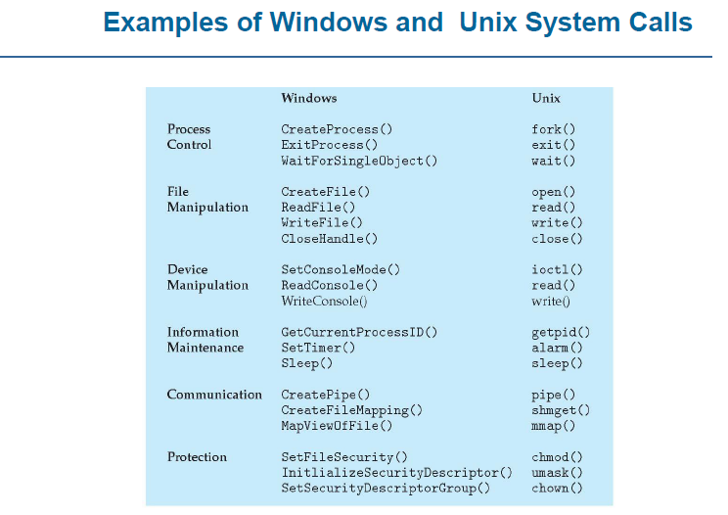

1. Process Creation:

The processes in most systems can execute concurrently, and they may be created and deleted dynamically. Thus, these systems must provide a mechanism for process creation and termination.

1. **fork()**

* Has a return value
* Parent process => invokes fork() system call
* Continue execution from the next line after fork()
* Has its own copy of any data
* Return value is > 0 //it’s the process id of the child process. This value is different from the Parents own process id.
* Child process => process created by fork() system call
* Duplicate/Copy of the parent process //LINUX
* Separate address space
* Same code segments as parent process
* Execute independently of parent process
* Continue execution from the next line right after fork()
* Has its own copy of any data
* Return value is 0

1. **wait ()**

* Used by the parent process
* Parent’s execution is suspended
* Child remains its execution
* On termination of child, returns an exit status to the OS
* Exit status is then returned to the waiting parent process //retrieved by wait ()
* Parent process resumes execution
* #include <sys/wait.h>
* #include <sys/types.h>

1. **exit()**

* Process terminates its execution by calling the exit() system call
* It returns exit status, which is retrieved by the parent process using wait() command
* EXIT_SUCCESS // integer value = 0
* EXIT_FAILURE // integer value = 1
* OS reclaims resources allocated by the terminated process (dead process) Typically performs clean-up operations within the process space before returning control back to the OS
* _exit()
* Terminates the current process without any extra program clean-up
* Usually used by the child process to prevent from erroneously release of resources belonging to the parent process

1. **execlp() is a version of exec()**

* **exec()**
* The exec family of functions replaces the current running process with a new process. It can be used to run a C program by using another C program.an executable file
* Called by an already existing process //child process
* Replaces the previous executable //overlay
* Has an exist status but cannot return anything (if exec() is successful) to the program that made the call //parent process
* Return value is -1 if not successful
* Overlay => replacement of a block of stored instructions or data with another int execlp(char const *file_path, char const *arg0, );
* Arguments beginning at arg0 are pointers to arguments to be passed to the new process.
* The first argument arg0 should be the name of the executable file.
* Example
* **execlp( /bin/ls , ls ,NULL) //lists contents of the directory**
  1. **but exec or execlp is a system call which overwrites an already existing process (calling process), so if you want to execute some code after execlp system call, then write this system call in a child process of an existing process, so it only overwrite child process.**
* Header file used -> unistd.h

1. **Information Maintenance**
2. **sleep()**

* Process goes into an inactive state for a time period
* Resume execution if
* Time interval has expired
* Signal/Interrupt is received
* Takes a time value as parameter (in seconds on Unix-like OS and in milliseconds on Windows OS)
* sleep(2) // sleep for 2 seconds in Unix
* Sleep(2*1000) // sleep for 2 seconds in Windows

1. **getpid() // returns the PID of the current process**

* getppid() // returns the PID of the parent of the current process
* Header files to use
* #include <sys/types.h>
* #include <unistd.h>
* getppid() returns 0 if the current process has no parent

**Example**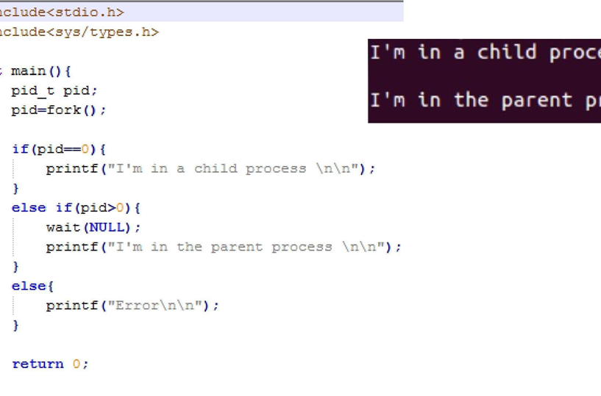

**InLab Questions:**

**Question No 1**

Write a C++ which performs following tasks.

Create a parent and child process using the fork command where the child tells if the number is odd or not and parent process will write the number on screen.

**Question No 2**

Create a program named stat that takes an integer array as command line argument (deliminated by some character such as $). The program then creates 3 child processes each of which does exactly one task from the following:

• Adds them and print the result on the screen. (Done by child 1)

• Shows average on the screen. (Done by child 2)

• Prints the maximum number on the screen. (Done by child 3)

**Question No 3**

Write a C++ program which executes the following commands using fork & execlp. (Hint: You will need to create three child processes, and each child process will execute one command using execlp)

1. mkdir ./myFolder_1 ./my_Folder2
2. mkdir ./myFolder_1/mySubFolder
3. ls -S

Note: You have to submit a makefile of these questions aswell.